- Data published around the turn of the year was consistent with the downbeat mood that characterised the latter months of 2024. We will publish our new UK forecast at the end of next week, and we expect to cut our projection for GDP growth in 2025 to around 1%.
- Consumers remain central to growth prospects this year. Recent data have been stronger. But real income growth is likely to be much weaker this year than last, and the recent surge in wholesale gas prices suggests the risks are skewed to the downside. So households must shed the extreme caution of 2024 if the momentum behind the consumer recovery is to be sustained.
Near-term growth prospects became ever gloomier in the latter months of 2024. And data published either side of the Christmas break provided further evidence of a loss of momentum, ensuring that our forecast for GDP growth in 2025 is likely to drop close to 1% when we publish our new forecast next week.
The Office for National Statistics published the Quarterly National Accounts for Q3 2024 shortly before the Christmas break. Quarterly growth was cut by 0.1ppts in both Q2 and Q3, meaning that GDP is now estimated to have been flat in the third quarter. Given the monthly data for October, we estimate that Q4 was only marginally better.
But it's not all bad news. The expenditure breakdown for Q3 looked much more solid than the headline GDP outturn, with consumer spending and business investment both growing strongly for a second successive quarter (Chart 1). We also have some suspicions that softer readings for Q3 in each of the past three years is indicative of a problem with residual seasonality that has emerged since the pandemic.
So we expect H2 2024 to prove to be a blip, rather than the start of a sustained slowdown. But the lack of momentum coming into this year means that calendar year growth in 2025 is unlikely to be much of a step up on 2024. Indeed, in the absence of favourable revisions, quarterly GDP growth must average just over 0.7% – a rate achieved just once in the past two years – to achieve the Office for Budget Responsibility's forecast of 2% growth in 2025.
Chart 1: The expenditure breakdown looks more solid than the headline GDP data
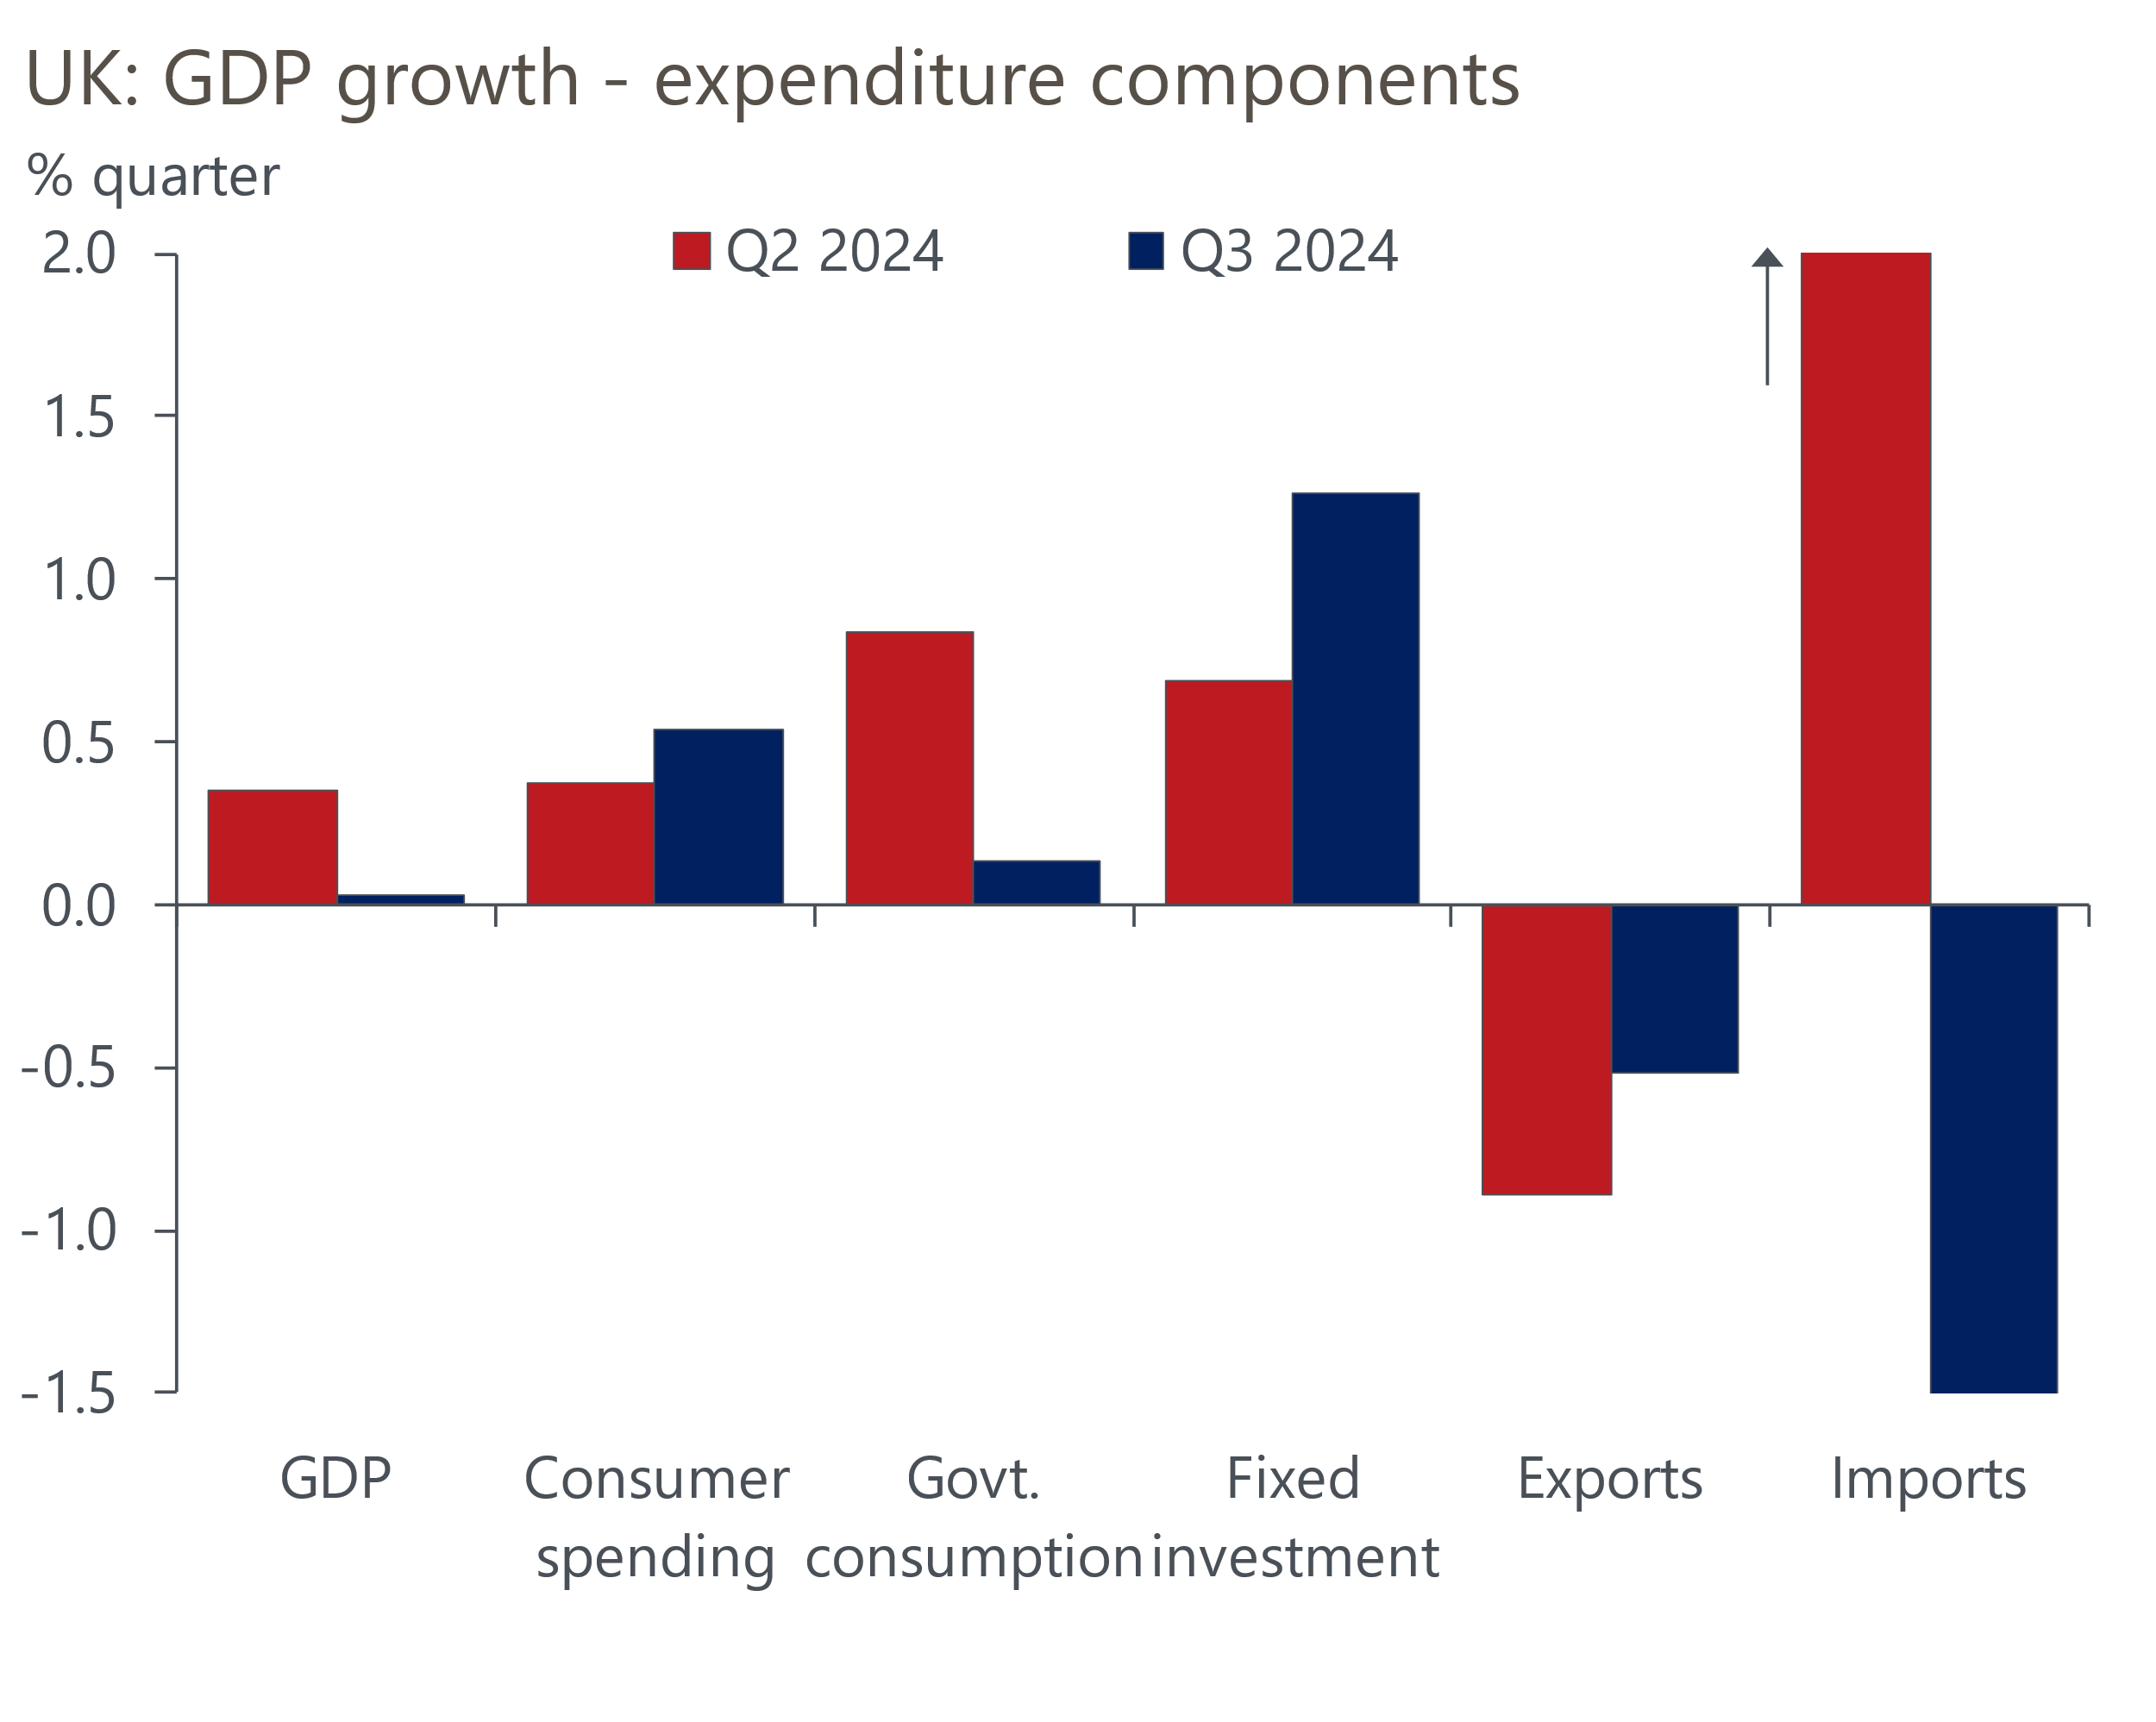
Source: Haver Analytics

The OBR's bullish forecast is heavily dependent on very strong growth in government consumption. But the revised Q3 data suggested that the over-spend identified by the Treasury shortly after Labour came to power has had little impact on real activity so far. We expect this to remain the case in 2025.
Consumers will be key to the strength of GDP growth this year, and the data in this area remains mixed. The national accounts reported much weaker real income growth in Q3 2024, after a very strong H1, which meant the saving ratio dropped a little. However, at 9.7% for households and non-profit making institutions serving households, the saving ratio was nearly 2ppts higher than the 2010-2019 average.
The Bank of England's Money & Credit release for November suggested that households' cautious mood persisted in Q4. As a share of the outstanding stock, repayments of credit card debt have only ever been higher twice than November's outturn (Chart 2). This was a key factor behind net unsecured lending edging down to a five-month low that month.
Chart 2: Very high levels of debt repayment suggest consumers remain cautious
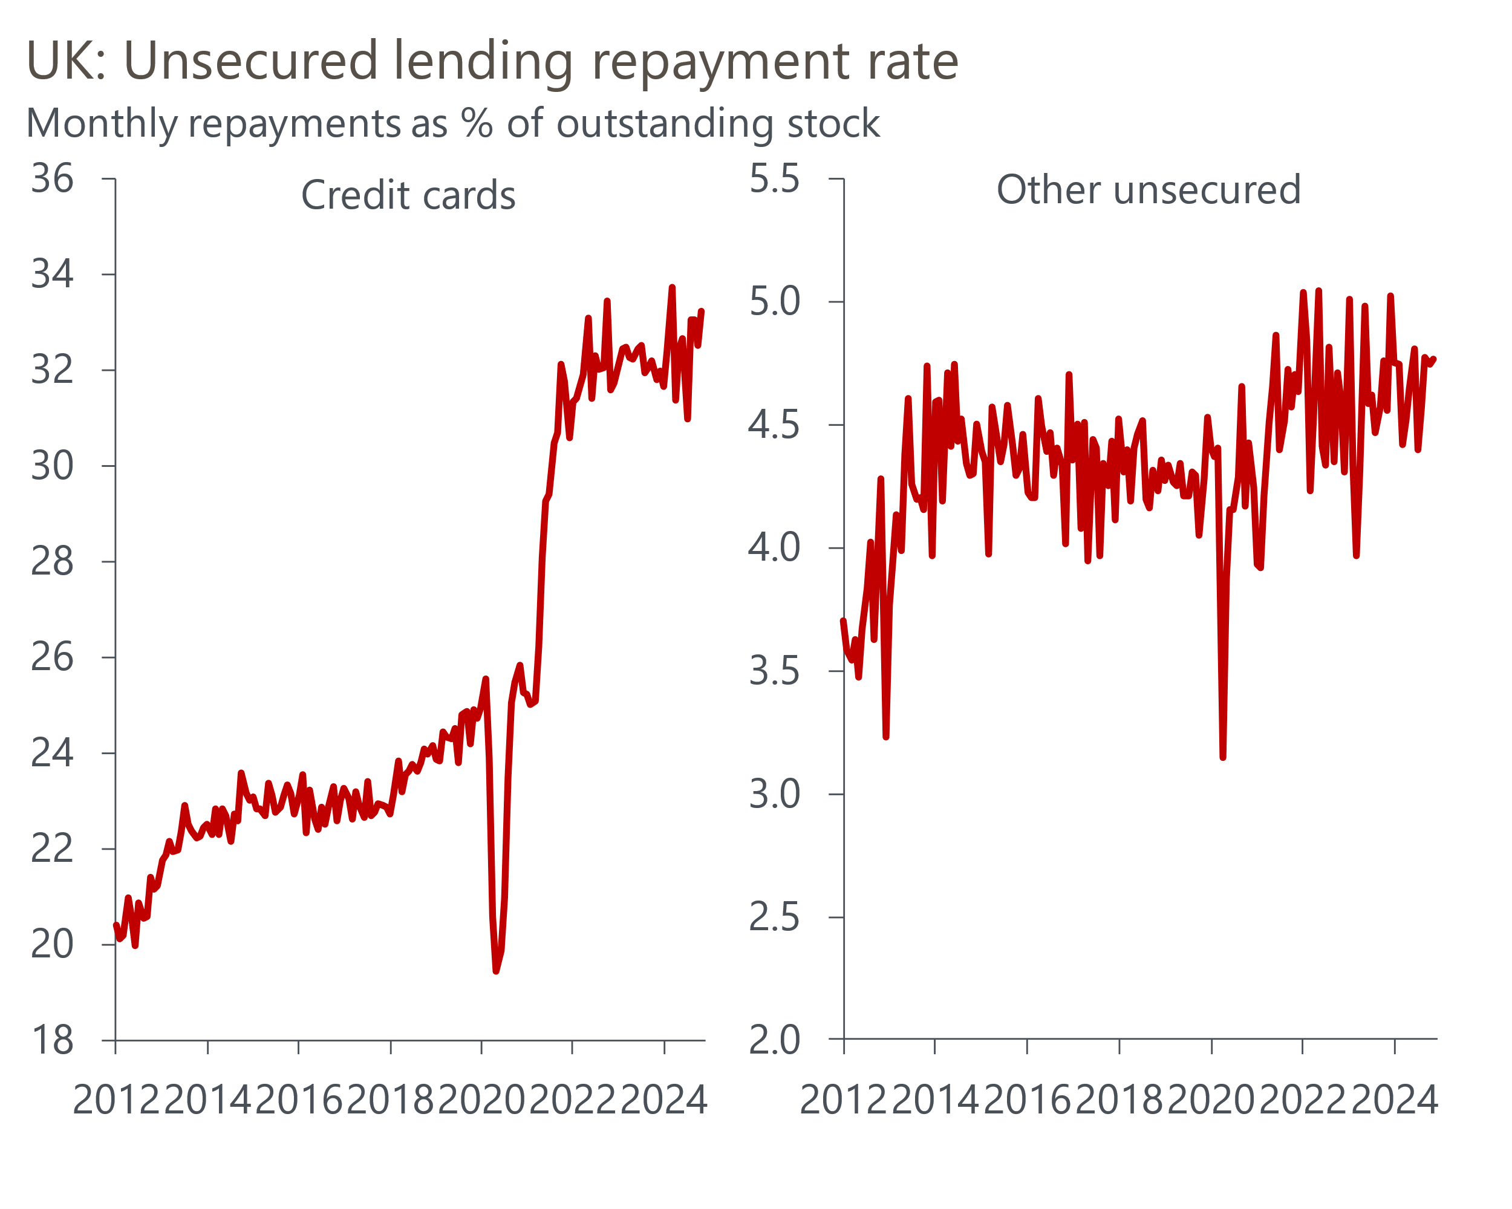
Source: Oxford Economics calculations using data from Haver Analytics
The caution also appears to have extended to the housing market, one of the rare bright spots of recent months. The Money & Credit release reported a surprise fall in mortgage approvals in November, reversing October's strong gain. November's outturn was even more disappointing given this should have been the period when there was the biggest boost from buyers setting purchases in train to try to complete before the March 2025 end to the temporary reduction in stamp duty thresholds. The current situation is in marked contrast to the experience of 2021 when there were sharp rises in activity ahead of similar increases in thresholds. That there was some evidence of this effect in the price data – Nationwide reported that house prices rose 0.7% month-on-month in December, on the back of a 1.2% increase in November – suggests that a limited number of properties for sale might be a factor in the weakness of approvals.
We've long expected real income growth to slow to close to 1% this year, as pay growth cools and inflation temporarily increases, so it's vital that consumers shed their caution if the momentum behind the recovery in spending growth is to be sustained. Indeed, recent movements in energy prices suggest the risks are skewed towards real income growth coming in even weaker. Wholesale gas prices have risen sharply in recent weeks and – if sustained – we could see the energy price cap rise by a further 6% in April, after the 1.2% increase that came into force this week.
That the saving ratio is still so high suggests there's plenty of scope for further dis-saving, while recent data from the GfK consumer confidence barometer suggests sentiment is slowly improving. So we think it's plausible that consumer spending will grow a little faster than real incomes this year. But even factoring in such a boost, it's hard to make the case for growth this year being much stronger than the 0.8% we estimate the UK achieved in 2024. We will publish our new forecast as part of our global forecast update on January 10, and it's likely we will cut our projection for 2025 GDP growth to somewhere in the region of 1%-1.1%.

The week ahead
Next week's only noteworthy releases are December's remaining S&P Global surveys and the Bank of England's Decision Maker Panel. The flash S&P Global survey reported a modest pickup in the pace of services activity, though the PMI of 51.4 was still well down on the results reported earlier in 2024. With the final manufacturing output balance coming in at an 11-month low, the composite PMI is likely to be only just above the 50 mark that separates expansion from contraction.
The construction PMI has been far stronger than its manufacturing and services counterparts in recent months, driven by robust performances in the commercial and civil engineering sub-sectors. We expect this out-performance to have continued in December, though the gap may begin to narrow if concerns about tax rises begin to weigh on sentiment in a similar fashion to the other sectors.
Table 1: Week ahead calendar
Date | Events | Period | Measure | Unit | Previous | Forecast
Jan 6 | S&P Global services | Dec | PMI | % bal | 51.4 | 51.4
Jan 6 | S&P Global composite | Dec | PMI | % bal | 50.5 | 50.5
Jan 7 | Halifax house prices | Dec | m/m | % | 1.3 | 0.5
Jan 7 | Halifax house prices | Dec | y/y | % | 4.8 | 4.3
Jan 7 | S&P Global construction | Dec | PMI | % bal | 55.2 | 54.5
Source: Oxford Economics

Key forecasts
Table 2: UK forecast overview
(Annual percentage changes unless specified)
 | 2022 | 2023 | 2024 | 2025 | 2026 | 2027
GDP | 4.8 | 0.3 | 0.9 | 1.4 | 1.7 | 1.8
Private consumption | 7.3 | 0.5 | 0.8 | 1.7 | 1.5 | 1.6
Fixed investment | 5.1 | -0.1 | 1.0 | 0.8 | 3.4 | 2.5
Government consumption | 0.6 | 0.6 | 2.4 | 2.9 | 1.6 | 1.6
Exports of goods and services | 12.6 | -2.2 | -1.9 | 1.9 | 1.6 | 1.5
Imports of goods and services | 13.0 | -3.4 | 2.5 | 2.2 | 1.8 | 1.5
Industrial Production | -6.4 | -1.2 | -1.1 | 0.6 | 1.2 | 1.1
Consumer prices | 9.1 | 7.3 | 2.6 | 2.8 | 2.3 | 2.1
Unemployment rate (%) | 3.9 | 4.0 | 4.3 | 4.4 | 4.3 | 4.2
Current a/c balance (% of GDP) | -2.2 | -2.0 | -3.1 | -2.8 | -2.8 | -2.7
Government balance (% of GDP) | 4.1 | 5.0 | 4.5 | 3.7 | 2.9 | 2.2
Central bank policy rate (%, EOP) | 3.50 | 5.25 | 4.75 | 3.75 | 3.00 | 2.50
10yr govt. bond yield (%, EOP) | 3.67 | 3.54 | 4.30 | 4.16 | 3.79 | 3.41
Exchange rate (US$ per £, EOP) | 1.20 | 1.27 | 1.26 | 1.27 | 1.27 | 1.28
Exchange rate (euro per £, EOP) | 1.13 | 1.15 | 1.20 | 1.20 | 1.20 | 1.20
Source: Oxford Economics
Table 3: Quarterly forecasts for the UK
 | 2024 |  |  |  | 2025
 | Q1 | Q2 | Q3 | Q4 | Q1 | Q2 | Q3 | Q4
GDP (% year) | 0.3 | 0.7 | 1.0 | 1.7 | 1.4 | 1.3 | 1.5 | 1.5
CPI inflation (% year) | 3.5 | 2.1 | 2.1 | 2.5 | 2.7 | 2.7 | 3.1 | 2.8
Bank Rate (%, EOP) | 5.25 | 5.25 | 5.00 | 4.75 | 4.50 | 4.25 | 4.00 | 3.75
10yr gilt yield (%, EOP) | 3.95 | 4.17 | 4.00 | 4.30 | 4.28 | 4.27 | 4.23 | 4.16
US$ per £ (EOP) | 1.26 | 1.26 | 1.34 | 1.26 | 1.26 | 1.26 | 1.27 | 1.27
Euro per £ (EOP) | 1.17 | 1.18 | 1.20 | 1.20 | 1.20 | 1.20 | 1.20 | 1.20
Source: Oxford Economics

Latest Country Economic Forecast:
December 10, 2024

Recent publications

Data Insights
Surprise fall in mortgage approvals in November
Manufacturing PMI ended 2024 on a disappointing note
Downwards growth revision confirms Q3 slowdown
Changes in market pricing more important than borrowing data
Retail sales edged up in November after successive falls

Research Briefings
December hold, but MPC still on track to cut in February
MPC preview – No urgency to switch up the tempo
Why Bank Rate will fall further than markets think
Key themes 2025 – Worrying debt dynamics shift into focus
Why the energy shock persisted for firms, but may soon fade

Contacts

Oxford Economics' UK team
- Andrew Goodwin - Chief UK Economist - agoodwin@oxfordeconomics.com
- Edward Allenby - UK Economist - eallenby@oxfordeconomics.com

